Name |  | S. Padmavathi |  |  |  |  |  | 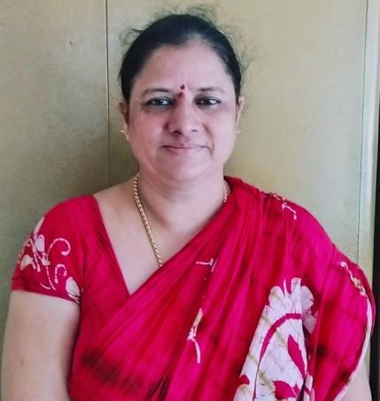
Designation |  | Lecturer in Botany
Employee ID |  | 2227672
Email |  | apb1904@gmail.com
Mobile No. |  | 8106543229
Date of Birth |  | 26-02-1973
Address |  | Flat No.403, 4th Floor,
 |  | Ramsan estate Apartment
 |  | Ram Nagar, Visakhapatnam-530 002
 |  | Andhra Pradesh State.
Educational Qualifications |  |  |  |  | P.G. - M.Sc.,
Specialization:
- Plant biotechnology
- Plant molecular genetics
 |  |  |  |  | Others:-- APSET
Date of First Appointment |  |  |  |  | 25.01.2002 as Jr. College Lecturer through APPSC  21-05-2013 as Degree College Lecturer by promotion
Date of Retirement |  |  |  |  | 28-02-2035
Previous Position if any: |  |  |  |  | Jr. Lecturer (Intermediate Education, A.P) (2004 to 2013)
I)Orientation Course Attended
S.No. | Name of the Course |  | From - To |  |  | University/Institution
1 | Orientation Programme for  Junior Lecturers |  | 16-05-2007 to  18-05-2007 |  |  | Conducted by Board of Intermediate Education.,  Hyderabad, at Andhra University, Visakhapatnam
2 | Orientation Course |  | 24-11-2014 to 21-12-2014 |  |  | Academic Staff College, Andhra University,  Visakhapatnam
II) Refresher Course Attended:
S.No. | Name of the Course |  | From - To |  |  | University/Institution
1 | Refresher Course in Environmental Sciences |  | 11-03-2019 to  31-03-2019 |  |  | Academic Staff College, Andhra University,  Visakhapatnam
2 | SWAYAM ARPIT online course in Disaster Management |  | 21-11-2018 to 28-02-2019 |  |  | Nagpur University, Amba Vihar South Ambazari road, Nagpur, Maharashtra
3. | Refresher Course in Life Sciences |  | 24-02-2021 To 09-03-2021 |  |  | Sri Venkateswara University, Tirupati, Ap
Vi) Training Programmes/Faculty Development Programmes:
S.No | Title of Training  Programme |  |  | Date |  |  | Conducted By |  | Inter/National  / State |  | Participated/ Paper  Presented
1 | Orientation workshop on OER content development, MOOCS and MOODLE |  |  | 26-10-2018 to 31-10-2018 |  |  | Electronics &amp; ICT Academy, NIT, Warangal |  | Telangana State |  | Participated
2 | New knowledge on pedagogical methods and frontiers in emerging technologies |  |  | 13-07-2020 to 17-07-2020 |  |  | CCE, AP |  | National |  | Participated
3. | Revised accreditation framework by IQAC |  |  | 27-05-2020 to 02-07-2020 |  |  | IQAC, Arts College,Rajahmundry |  | National |  | Participated
4. | 5-day FDP in LMS |  |  | 03-08-2020 to 07-08-2020 |  |  | CCE, AP |  | National |  | Participated

III) International Seminars/ Workshops/Conference Attended:
Sl. No. | International | National | Papers presented |  | Participated
 |  |  | International | National | International | National
1. | 2 | 11 |  | 9 | 2 | 2
IV. International /National Publications:
S.No. | No. of Publications | International | National
1. | 4 | 3 | 1

V) Books Published:
1. “Biodiversity and phytoluxuriance as a way for eternal green globe” – Proceeding publication Book (June, 2016) published by
Vijayanarasimha Publishers, Hyderabad with ISBN: 978-81-931899-7-
- Projects: NA
- Memberships
VIII) ATTENDED AS RESOURCE PERSON
1 | Gene expression | 4th March, 2014 | Dept of Botany, GDC, Palakonda, Srikakulam Dt.
2. | Acted as Judge for Life Sciences, Zonal Level Science Fair held at VSP | 28-12-2020 to 30-12-2020
X) Achievements:
- Qualified APSET
- Convener & Organizing Secretary for Two-day National Seminar on “Biodiversity and phytoluxuriance as a way for eternal green globe” sponsored by UGC held on 29th & 30th January, 2016 at Visakha Govt. Degree College for Women, Visakhapatnam.

XI) Additional Responsibilities Held:
- HOD of Botany (2013-2021), and Coordinator for Green Club at Visakha Govt. Degree College (W), Visakhapatnam.
- Coordinator of Add on Certificate Course “Horticulture Techniques” at Visakha Govt. Degree College (W), Visakhapatnam.
- Member of NAAC Criterion VII at Dr.V.S.Krishna Govt. Degree College (A), Visakhapatnam.
- Member of Discipline committee at Dr.V.S.Krishna Govt. Degree College (A), Visakhapatnam.
- Attended as Academic Advisor to conduct Academic Audit on 15.09.2018 at SVVMC College for Degree and P.G. courses, Visakhapatnam.
- Member, JKC, at Dr.V.S.Krishna Govt. Degree College (A), Visakhapatnam.
- Worked as a translator for the translation project of SWAYAM, Conducted by IGNOU (Indira Gandhi National Open University), and translated 04 transcripts of Commercial Fruit production of Guava and Pomegranate and translated 07 videos of technology of fermented cheese and Ice cream byproducts

